ACTIVIDAD CLASE 8 MEMORIAS. MESA 4.

Alvarez, Soto Bejarano, Aquino, Zurbriggen.

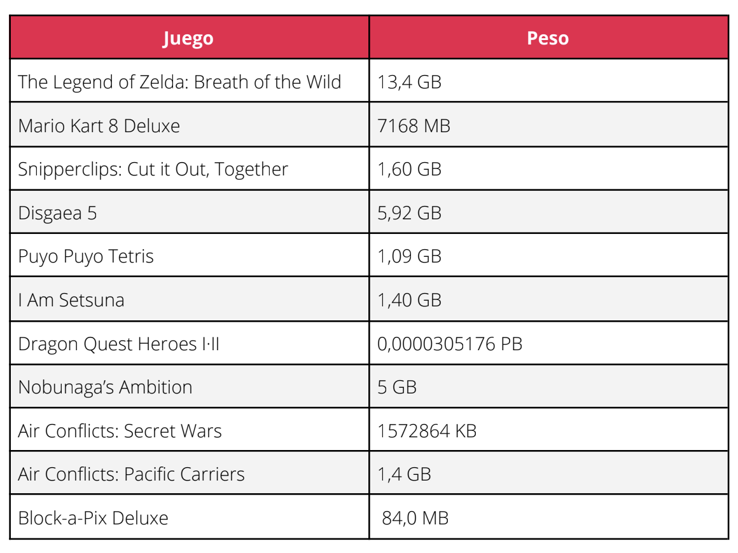

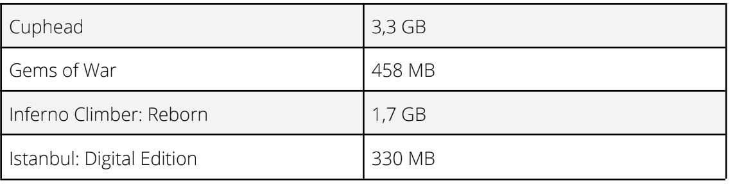

Instabul: 0,33GB

Mario Kart 8 Deluxe: 0,7168GB

Snipperclips: Cut it Out, together 1,6GB

Puyo puyo Tetris 1,09

I am Setsuna 1,4GB

Air conflicts: Secrets… 1,57GB

Air Conflicts: Pacific…1,4GB

Block-a-Pix Deluxe 0,84gb

Gems of war: 0,45GB

Inferno Climber: Reborn: 1,7

Cuphead: 3,3GB

Nobunaga: 5GB

Disgea 5: 5,92GB

SUMA: 25,316GB (13 juegos)